**Connect Four User Guide**

By Jun Hua Chen and Aleck Lu



This Program allows the user to play a stimulated version of the board game Connect Four.

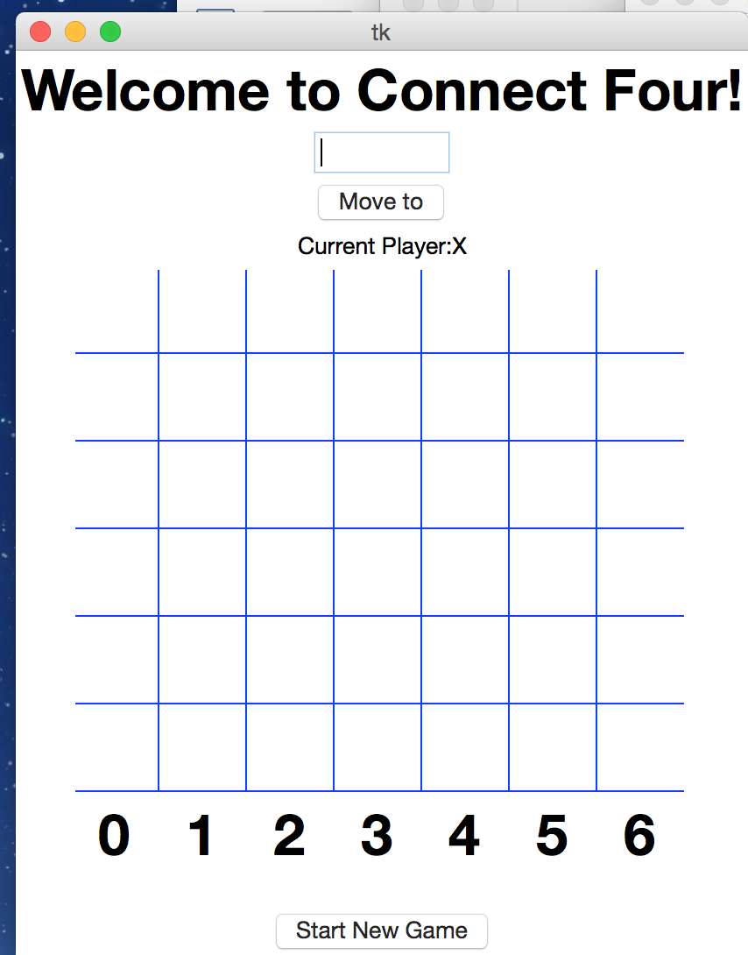

1. Default Screen – When the program is ran for the first time, there will be an empty board with column numbers labeled under it. To play, the user will input the column number that he/she wants to drop a piece to. By default, the Move To button is disabled until the column number is entered. Note: By default, Player 1 is X(Red)

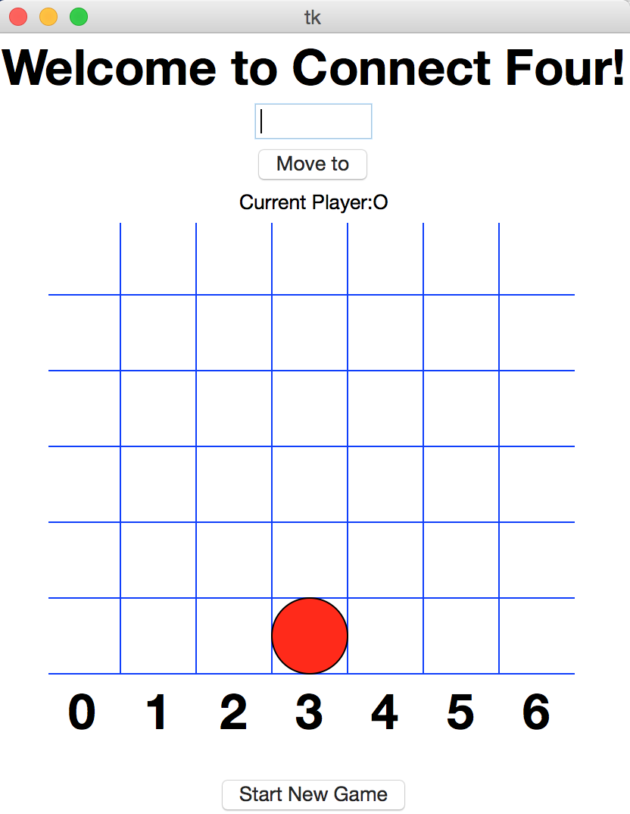

1. Playing the Game – In this example, the column 3 was inputted. The Move To button is enabled and pressed. The piece drops down to column 3. Note: The entry box will clear after the Move To Button is pressed.

However, if the box is empty and if a number that is not between 0 and 6 is entered, an error message will show up.

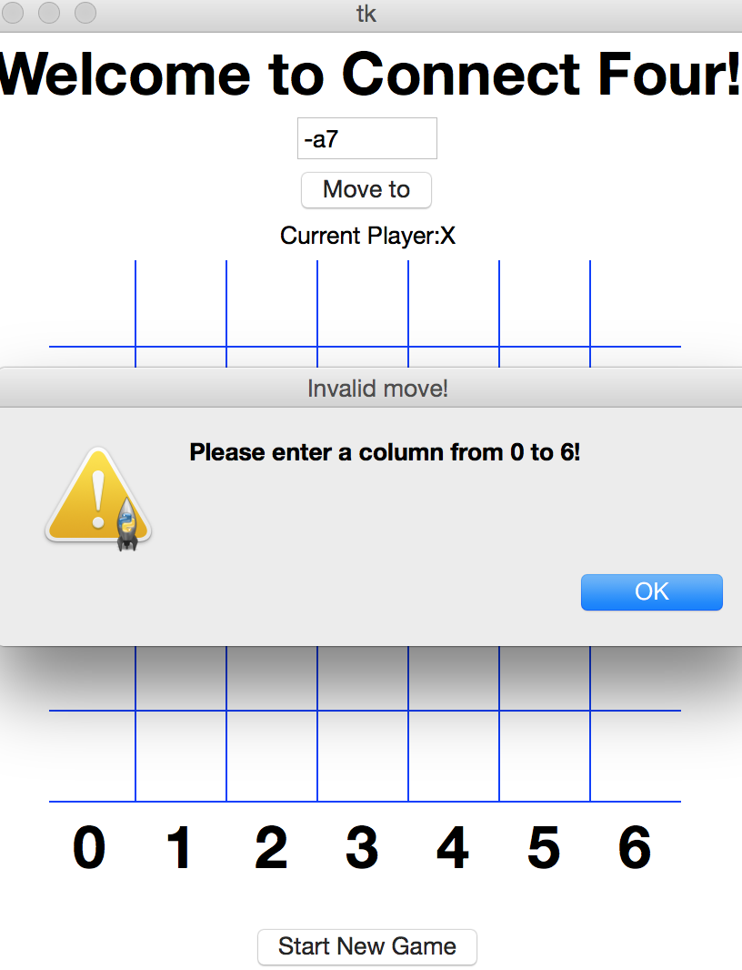

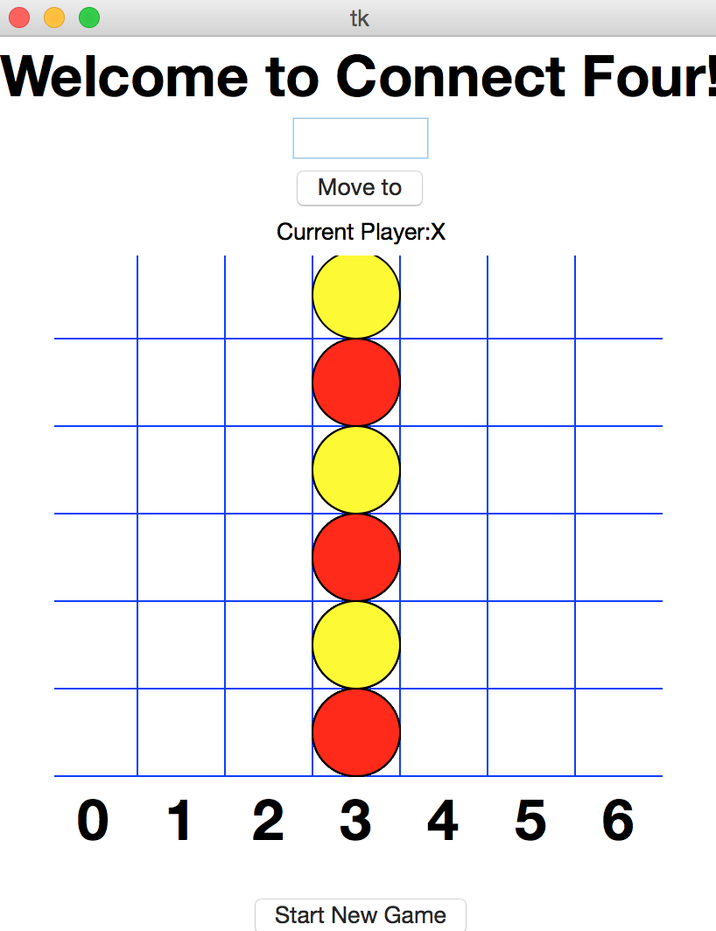

3.In this example, column 3 has been filled. If column 3 is inputted again by mistake, Current Player will not lose his turn and be able to input his choice of move again.

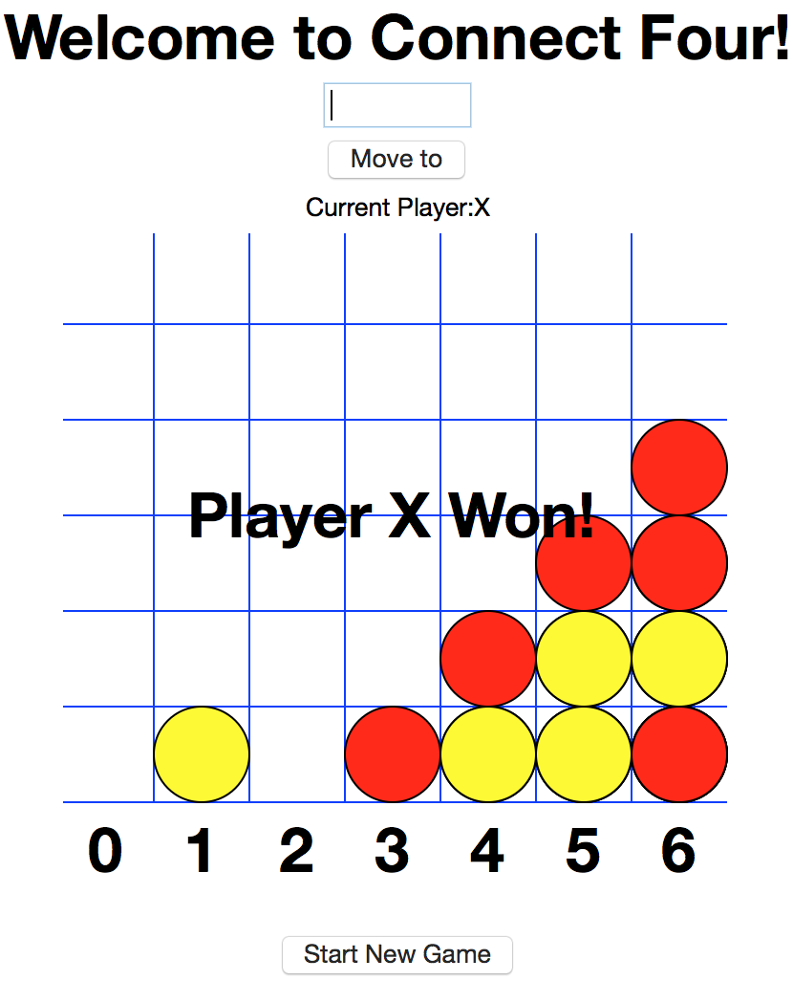

4. As shown in this example, once a player has connected 4 pieces in a row either horizontally, vertically, or diagonally, the game will end. The user can choose to refresh the board and start a new game using the Start New Game button located at the bottom of the screen. (Note: the Start New Game button can be pressed during any point of the game)

In cases where every spot of the game board has been filled and a Connect Four has not been achieved, the game will end in a draw.